Log into Connexion at: http://connexion.oclc.org/
In Connexion Under the “General Tab” Choose “Preferences”
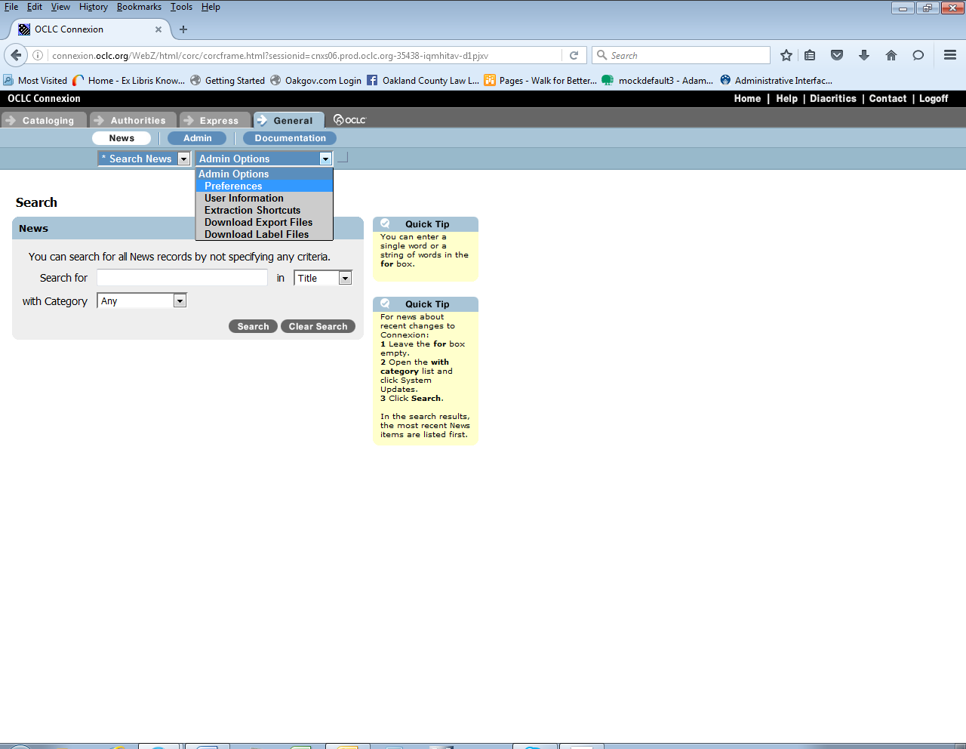
Click “Export Options”
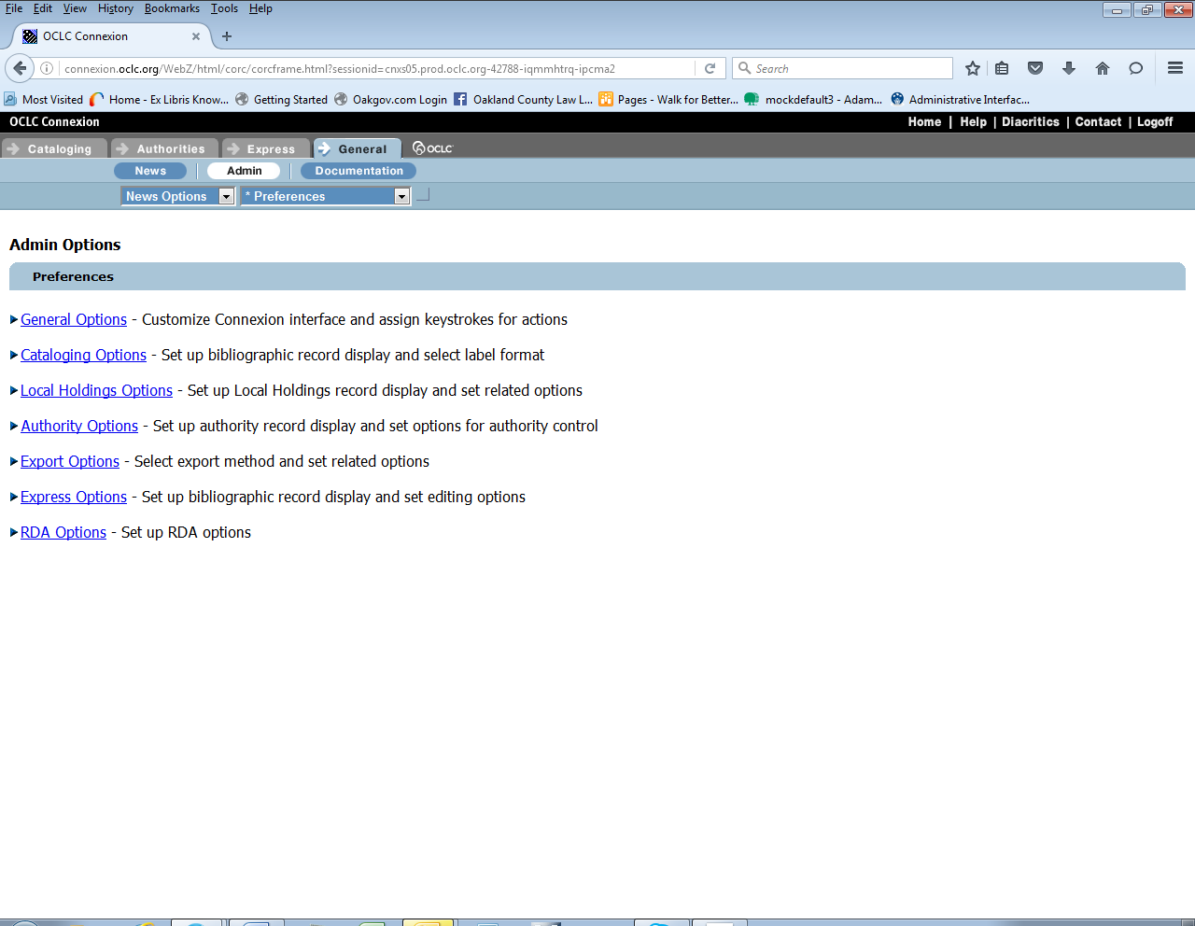
Here is the OCL Configuration (2 screenshots to show whole page):
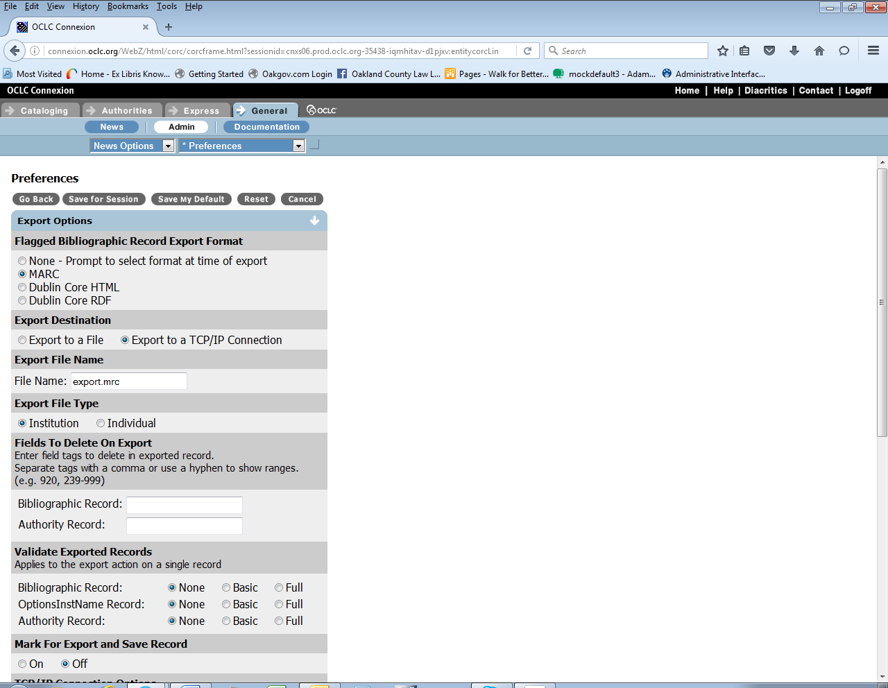

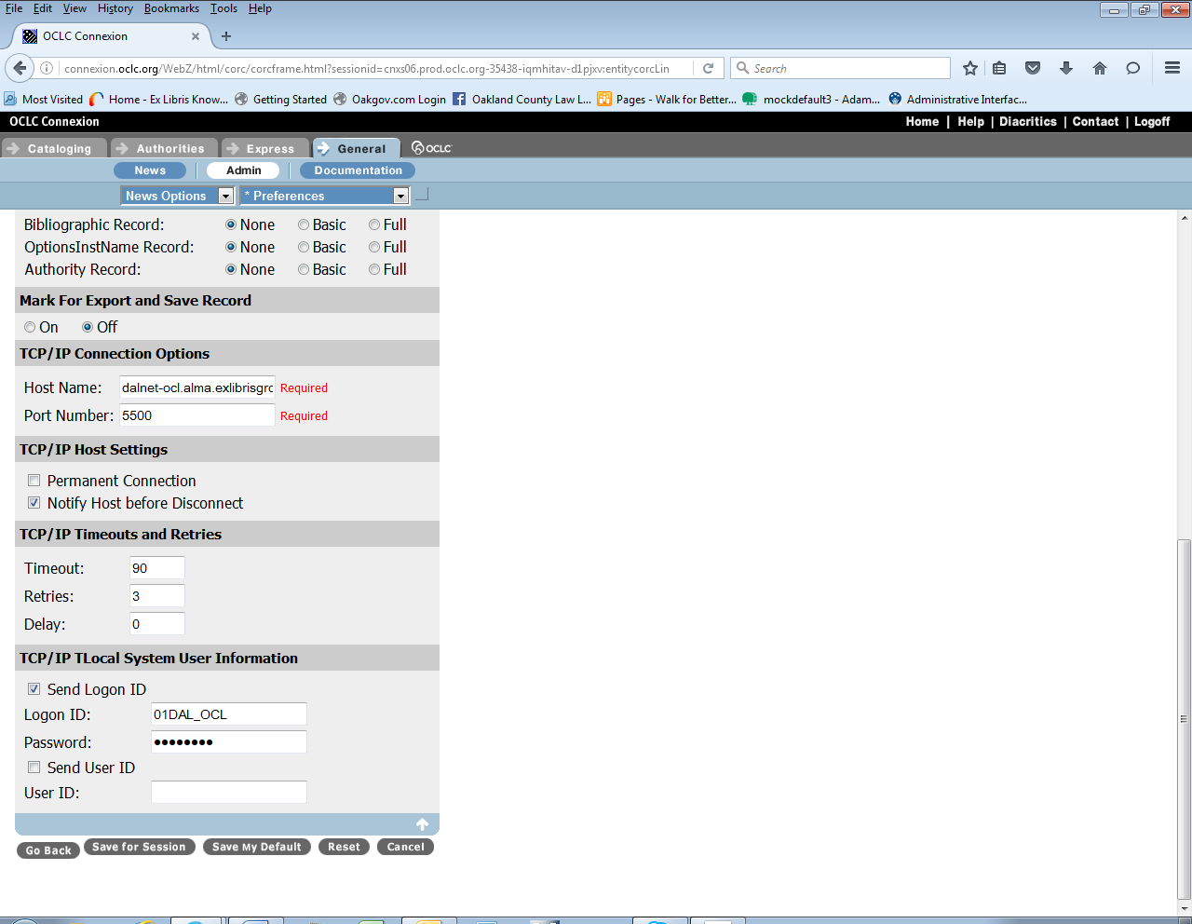

Click “Save My Default”

To Export a record, search for the bibliographic record in Connexion.
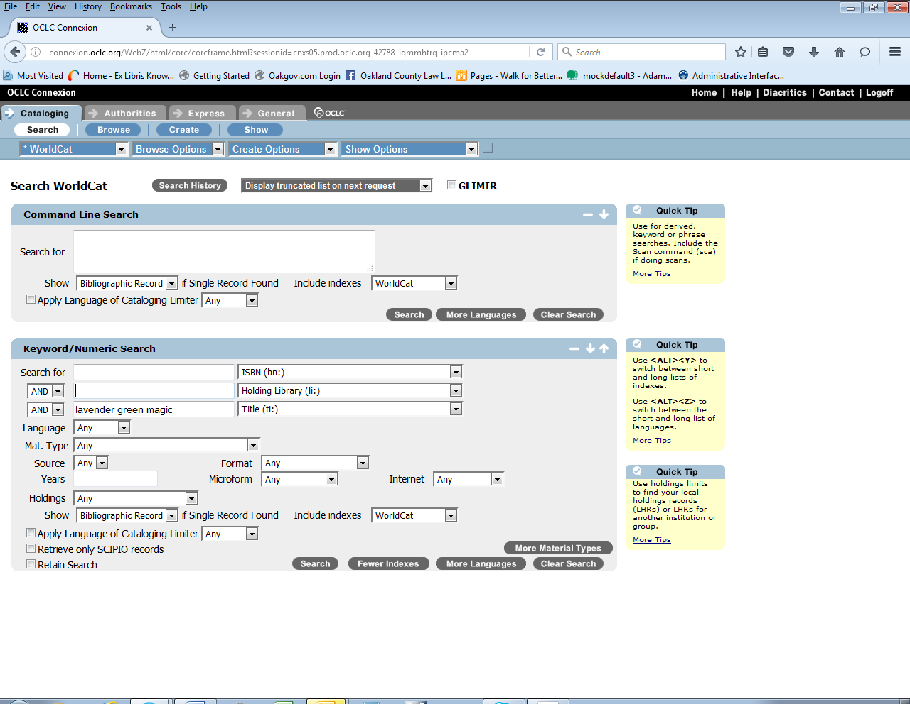

Under “Action” select “Export Record in Marc”.
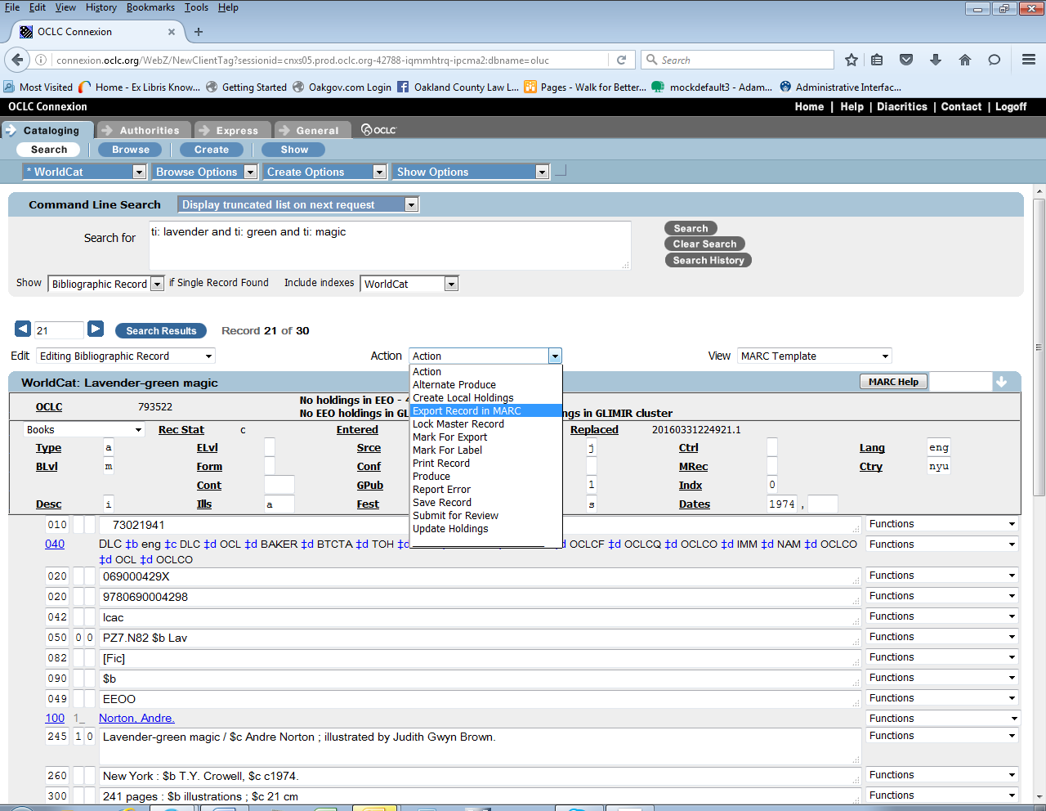

Go into Alma and search for bibliographic record.
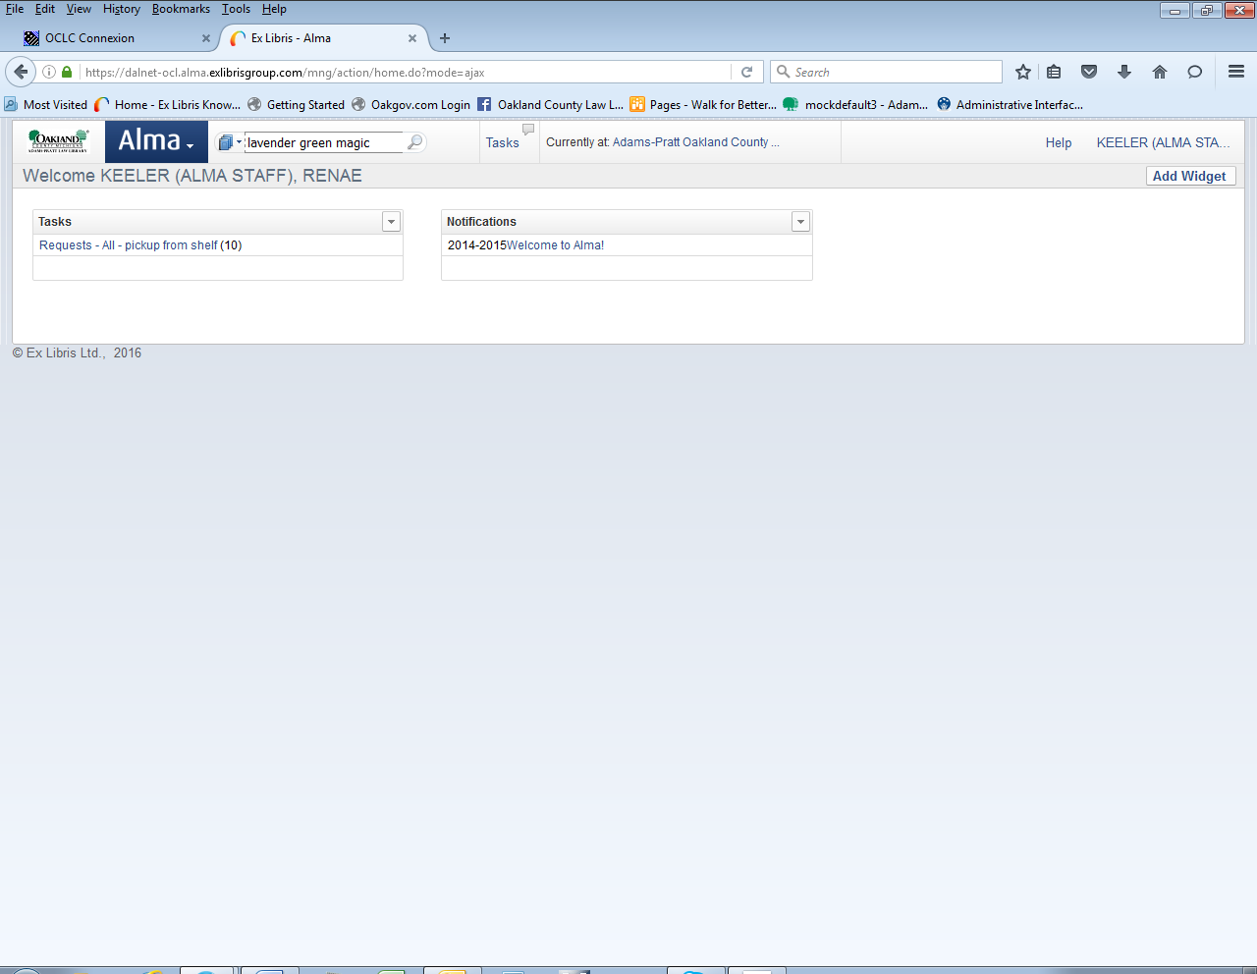

The bibliographic record should appear.
